# International Workshop: Optics for biology and medicine

# The Title

I. Ivanov1, J. Li2

1 Ioffe Institute, Saint Petersburg, 194021, Polytechnicheskaya, 26, Russia

2 Department of Biomedical Engineering, The Hong Kong Polytechnic University, Hong Kong SAR 000000, China

e-mail: ivanov@mail.ioffe.ru

This instruction is typed in the text editor MS Word, which should be used when preparing abstracts. The instruction is actually a template containing styles: Heading 1, Heading 2, Authors, Organizations, Contacts, Normal, Figure Caption, Numbered List, References. Styles should not be modified by the author, they should be applied according to their names.

## Abstract design

1. The text of the abstract should be typed or inserted into this template. Each individual piece of text should be designed using one of the styles provided in this template.
2. The drawings should be embedded in the text. All inscriptions on the drawing, as well as in the text, should use the font Times New Roman, 12 points. If necessary, the author may be asked to provide the original file. It is recommended to use vector graphics formats (*.eps, *.wmf). If it is necessary to use raster images, then *.tif format without compression with a resolution of at least 300 dpi is recommended.

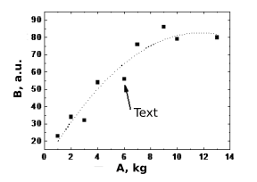

Fig. 1. Dependence of the value B on the parameter A

1. Mathematical notations should be typed using an editor Microsoft Equation: .
2. The recommended table format is shown below.

Table. 1. Fitting parameters

|  |  |  |
| --- | --- | --- |
| Fitting parameters | a | b |
| 1 | 2 |

1. The printed version of the abstract, including embedded figures and tables, should not exceed **1 page.**
2. References [1] and the list of cited literature are numbered with numbers in square brackets.

## References

[1] E.A. Tugova, V.V. Gusarov. *J. Alloys Compd*. 2011. 509 [5]. 1523-1528.

[2] *Spikes, J. D. Chapter 5 in The science of photomedicine p 113-144.. Boston, MA: Springer US, 1982.*